Support McVay When You Shop - Here’s 3 Easy Ways!
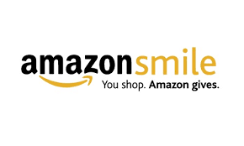
AmazonSmile: You Shop, Amazon Gives
Shop the same great products and prices on Amazon while supporting McVay! Amazonsmile Foundation will donate 0.5% of all eligible purchases to McVay. It’s easy to participate! Just shop the link below.
Shop for everyone on your gift list this holiday at http://smile.amazon.com/ch/31-1273686 and Amazon donates to PTA Ohio Congress McVay El PTA
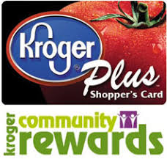
Shop Kroger, Swipe Card, and McVay Earns $!
Update your Kroger Rewards Card here: https://www.kroger.com/account/communityrewards/enroll
Select McVay Elementary (80775) for your Community Rewards Organization.
Shop at your local Kroger and swipe your Kroger card! It’s that easy!

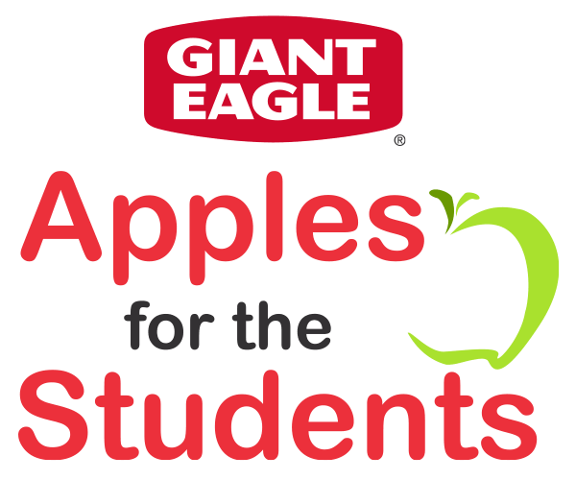
Shop Giant Eagle, Swipe Card, earn Mcvay points for cash! Easy!
Register your Giant Eagle Card here:
www.gianteagle.com/AFTS
Select McVay Elementary School (3407)

